Recall
In machine learning, "recall" is a performance metric used to evaluate the effectiveness of a classification model, particularly in binary classification tasks. It measures the ability of the model to correctly identify all relevant instances from a dataset, also known as the true positive rate.
In a binary classification problem, we have two classes: positive and negative. The terms "positive" and "negative" are not inherently meaningful and depend on the specific context of the problem. For example, in a medical diagnosis scenario, the positive class might represent patients with a particular disease, while the negative class represents patients without the disease.
Recall is calculated as the ratio of true positives (TP) to the sum of true positives and false negatives (FN):
Recall=True Positives (TP)True Positives (TP)+False Negatives (FN)Recall=True Positives (TP)+False Negatives (FN)True Positives (TP)​
Alternatively, it can be expressed as the complement of the false negative rate:
Recall=1−False Negative RateRecall=1−False Negative Rate
A high recall value indicates that the model is good at capturing relevant instances of the positive class, minimizing the number of false negatives. In other words, it indicates a low rate of missing positive instances.
Recall is particularly important in scenarios where the cost of missing positive instances (false negatives) is high. For example, in medical diagnosis, missing the detection of a disease can have severe consequences, so it's crucial to have a high recall rate even if it leads to some false positives.
In summary, recall provides insight into the ability of a classifier to identify all relevant instances of the positive class, making it an essential metric for evaluating the performance of classification models, especially in scenarios where detecting positive instances is of utmost importance.

Recall Example
Let's consider a binary classification problem where we are building a spam email detection system. The goal of the system is to classify incoming emails as either spam (positive class) or non-spam (negative class). In this context:
- True Positives (TP) are the emails that the model correctly identifies as spam.
- False Negatives (FN) are the emails that are actually spam but are incorrectly classified as non-spam by the model.
Now, let's illustrate recall using an example:
Suppose our spam email detection system processes 100 emails, out of which 30 are actually spam (positive class) and 70 are non-spam (negative class). After processing, the system makes predictions, and the results are as follows:
- True Positives (TP): The system correctly identifies 25 out of the 30 spam emails.
- False Negatives (FN): The system misses 5 spam emails and classifies them as non-spam.
In this scenario, we can calculate recall as follows:
Recall=True Positives (TP)True Positives (TP)+False Negatives (FN)Recall=True Positives (TP)+False Negatives (FN)True Positives (TP)​
=2525+5=25+525​
=2530=3025​
≈0.8333≈0.8333
So, the recall of our spam email detection system is approximately 0.8333, or 83.33%.

Precision
In machine learning, "precision" is a performance metric used to evaluate the effectiveness of a classification model, particularly in binary classification tasks. It measures the ability of the model to correctly identify the relevant instances from the predicted positive instances, also known as the positive predictive value.
In a binary classification problem, we have two classes: positive and negative. The terms "positive" and "negative" are not inherently meaningful and depend on the specific context of the problem. For example, in a medical diagnosis scenario, the positive class might represent patients with a particular disease, while the negative class represents patients without the disease.
Precision is calculated as the ratio of true positives (TP) to the sum of true positives and false positives (FP):
Precision=True Positives (TP)True Positives (TP)+False Positives (FP)Precision=True Positives (TP)+False Positives (FP)True Positives (TP)​
A high precision value indicates that the model is good at correctly identifying relevant instances from the predicted positive instances, minimizing the number of false positives.
Precision is particularly important in scenarios where the cost of false positives is high. For example, in an email spam detection system, misclassifying a non-spam email as spam can lead to important emails being missed, so it's crucial to have a high precision rate even if it leads to some missed spam emails.
In summary, precision provides insight into the ability of a classifier to avoid misclassifying negative instances as positive, making it an essential metric for evaluating the performance of classification models, especially in scenarios where avoiding false positives is of utmost importance.
Example
Let's continue with the example of a spam email detection system to illustrate precision.
Suppose our spam email detection system processes 100 emails, out of which 30 are actually spam (positive class) and 70 are non-spam (negative class). After processing, the system makes predictions, and the results are as follows:
- True Positives (TP): The system correctly identifies 25 out of the 30 spam emails as spam.
- False Positives (FP): The system incorrectly classifies 10 non-spam emails as spam.
In this scenario, we can calculate precision as follows:
Precision=True Positives (TP)True Positives (TP)+False Positives (FP)Precision=True Positives (TP)+False Positives (FP)True Positives (TP)​
=2525+10=25+1025​
=2535=3525​
≈0.7143≈0.7143
So, the precision of our spam email detection system is approximately 0.7143, or 71.43%.
This means that out of all the emails predicted as spam by the system, approximately 71.43% of them are actually spam. In other words, the system correctly identifies the relevant instances (spam emails) from the predicted positive instances with a precision of 71.43%. A higher precision value indicates that the system is better at avoiding misclassifying negative instances (non-spam emails) as positive (spam), minimizing the number of false positives.

Confusion Matrix
A confusion matrix is a table that is often used to describe the performance of a classification model on a set of test data for which the true values are known. It allows visualization of the performance of an algorithm, providing insight into the types of errors made by the model.
Let's illustrate the confusion matrix with an example using a binary classification problem, such as a medical diagnosis scenario where we are trying to predict whether patients have a certain disease or not.
Suppose we have built a binary classification model to predict whether patients have the disease (positive class) or not (negative class). After evaluating the model on a test dataset, we obtain the following results:
- True Positives (TP): 150 patients who actually have the disease were correctly classified as positive.
- True Negatives (TN): 850 patients who do not have the disease were correctly classified as negative.
- False Positives (FP): 50 patients who do not have the disease were incorrectly classified as positive.
- False Negatives (FN): 50 patients who actually have the disease were incorrectly classified as negative.
Based on this information, we can construct the confusion matrix:
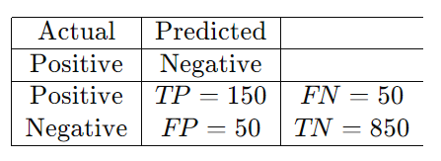
Here's how to interpret the confusion matrix:
- True Positives (TP): These are the cases where the model correctly predicts the positive class (patients with the disease).
- True Negatives (TN): These are the cases where the model correctly predicts the negative class (patients without the disease).
- False Positives (FP): These are the cases where the model incorrectly predicts the positive class (patients without the disease but classified as having the disease).
- False Negatives (FN): These are the cases where the model incorrectly predicts the negative class (patients with the disease but classified as not having the disease).
From the confusion matrix, we can calculate various performance metrics such as accuracy, precision, recall, and F1-score, which provide valuable insights into the performance of the classification model.

Accuracy and F1 Score
Let's continue with the same example of a binary classification problem in a medical diagnosis scenario where we are trying to predict whether patients have a certain disease or not.
Suppose we have the following results from our classification model:
- True Positives (TP): 150
- True Negatives (TN): 850
- False Positives (FP): 50
- False Negatives (FN): 50
We can use these values to calculate accuracy and F1-score.
- Accuracy:
Accuracy measures the overall correctness of the model across all classes and is calculated as the ratio of correctly predicted instances (TP and TN) to the total number of instances.
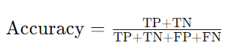
Substituting the values from our example:
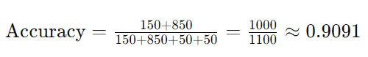
So, the accuracy of our classification model is approximately 0.9091 or 90.91%.

- F1-Score:
The F1-score is a harmonic mean of precision and recall. It provides a balance between precision and recall and is particularly useful when there is an uneven class distribution (class imbalance) in the data.
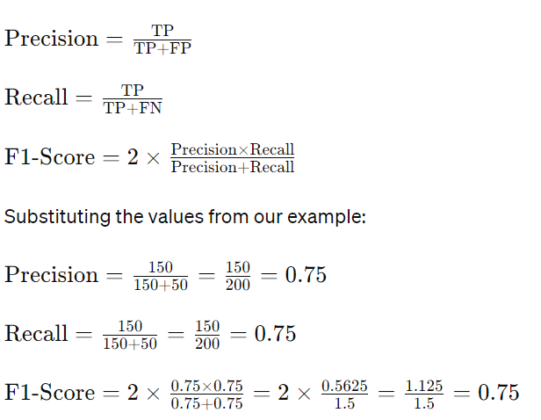
So, the F1-score of our classification model is 0.75.
In summary, accuracy measures the overall correctness of the model, while the F1-score provides a balance between precision and recall, making it a useful metric in scenarios with uneven class distributions.

